- Create a design from the given figure.

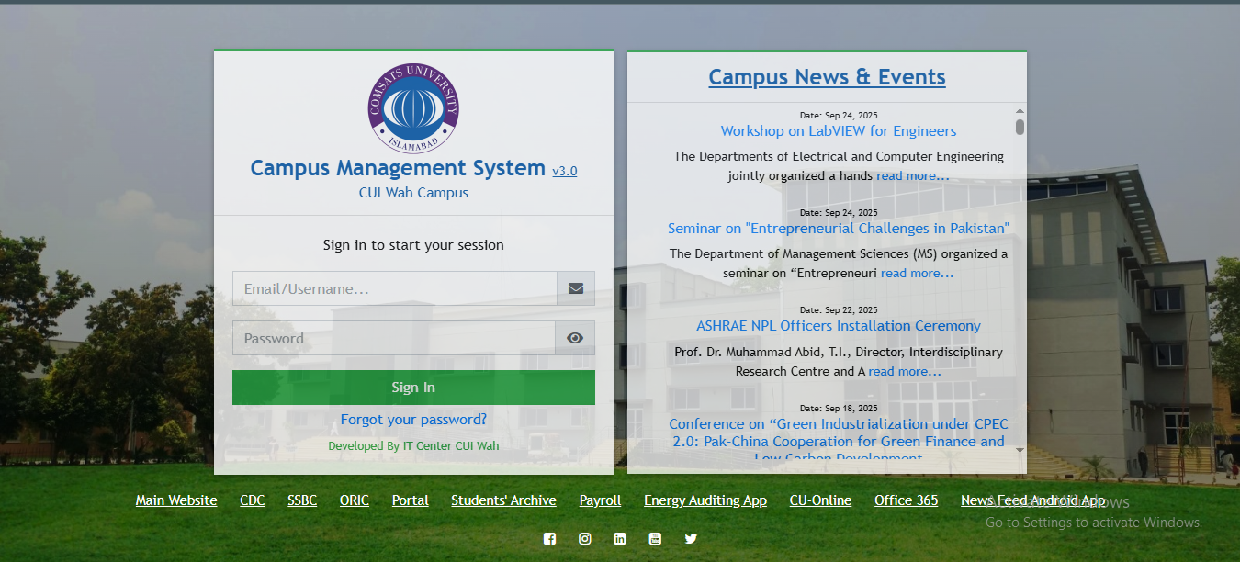
- Create a design from the given figure.
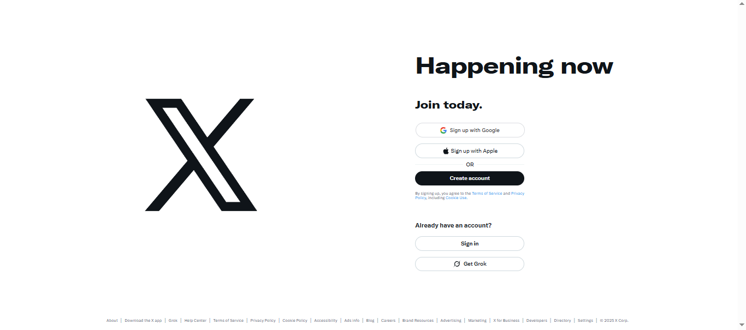



- Create a design from the given figure.

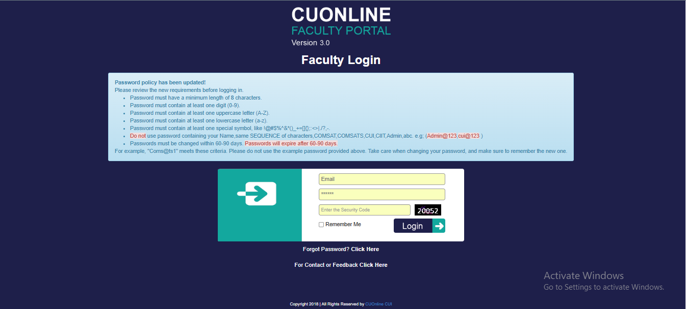

- Create a design from the given figure.
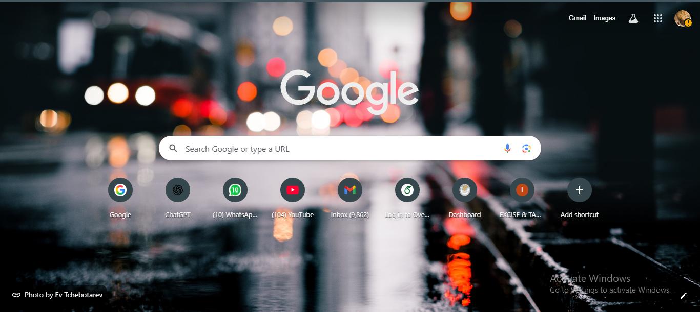
- The registration form should collect the following information: Name, Email, Password Gender (radio buttons), Country (dropdown menu) Skills (checkboxes), Upload Resume only pdf, Portfolio link (URL input) Cover letter, Availability (date input) Submit and Reset buttons.

